# **Currency Converter**

**Introduction:**

An application is to be developed to represent dynamic functionalities like online currency converter. The application can simultaneously convert to currency using an online information source.Different countries use different currencies and these currencies change daily compared to each other. Those who have transferred money (one currency to another) from one country to another must be updated with the latest currency exchange rates in the market.With this in mind, the Currency Converter project has been created. This is just an app development like a calculator using Python. In this application, there are regular updates about each country's currency by which it reflects the current currency market value and conversion rate.Such an application can be used by any user, but it is mainly useful for business, shares and finance related areas where money transfer and currency exchange takes place daily.

**Problem Statement:**

Creating a real-time currency converter that will take data from authenticated sources that are looking to invest abroad or perhaps going on holiday will reduce the time it takes to serve customers and they need local currency and cryptocurrency to buy goods.

Literature Survey: Sergio Bianchi, Alexandre Pantanella, and Augusto Pianese, “Modeling and Simulation of Currency Exchange Rates Using Multifractional Process with Random Exponent”[1], In this work, we propose simulation algorithms capable of replicating a special time series related to the FMS market, assuming a multilingual process model with a random exporter (MPRE). We show how to properly select the functional parameters of the MPRE, how the simulated series fits with significant accuracy in real estate. It is beneficial to underline that knowledge of functional parameters alone ensures that surrogates succeed in copying empirical data. The results can be used in situational analysis as well as in estimation.Dr. S. Kumar Chandar, Dr. M. Sumathi, Dr S. N. Sivanandam, “ Forecasting of Foreign Currency Exchange Rate Using Neural Network” [2], The foreign exchange market is the largest and most important in the world. Foreign exchange transactions are the simultaneous sale of one currency and the purchase of another currency. It is essential for currency trading in the international market. In this paper, we have examined predictive modeling based on artificial neural techniques based on foreign exchange rates using five different training algorithms. The model was trained using historical information to estimate the four foreign exchange rates against the Indian rupee. Predictive performance of the proposed system is performed using statistical metrics and compared. From the results it became clear that the new approach provides a technique to improve foreign exchange rate forecasting. It is also an effective tool and can be predicted significantly closer using simple design. Out of the five models, the Levenberg-Markart based model lags behind the other models and achieves comparative results. It also demonstrates the power of the proposed approach and makes more accurate predictions. Finally, the proposed scheme can significantly improve estimation performance when calculated on three commonly used metrics.Yoke Leng Yonga, Yunli Leea, Xiaowei Gu, Plamen P Angelov, David Chek Ling Ngo, Elnaz Shafipour, “Foreign currency exchange rate prediction using neuro-fuzzy systems”[3].

Proposed System (Block Diagram):

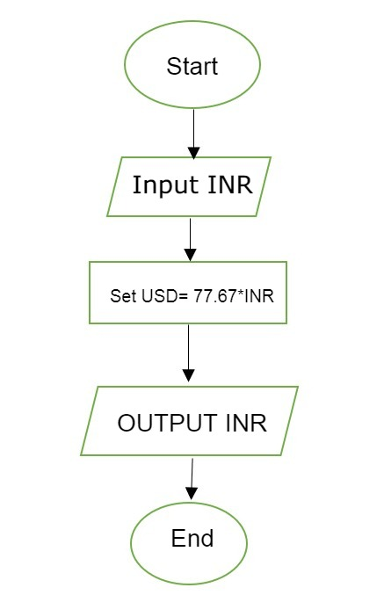

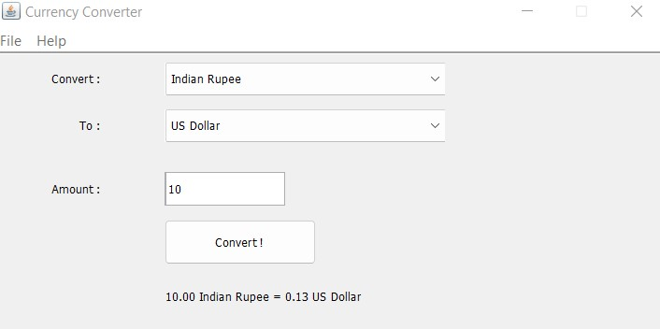

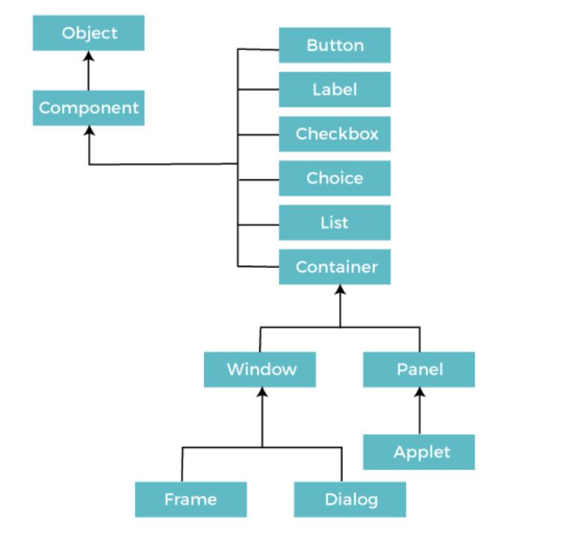

**Financial Feasibility:**

Operational Feasibility: It is the ability to utilize, support, and perform the necessary tasks of a system such as collecting data from various websites, filtering them, and storing them in the database server. As per the user's choice user sets the base currency, then accordingly shows the user the currency exchange rates, trends from the data that is fetched from the database server of currency monitoring websites. Similarly, the news feed. is fetched through forex market news-related websites through API calls.

**Literature Survey Summary:**

Minakhi Rout, Babita Majhi, Ritanjali Majhi, Ganapati Panda, “Forecasting of currency exchange rates using an adaptive ARMA model with differential evolution based training ”[4], Soft and evolutionary computer -based techniques have been introduced in the literature to overcome the limitations of statistically based methods of estimating exchange rates. To conduct research in this direction , this paper proposes a simple but promising hybrid estimation model by combining Autoregressive Moving Average (ARMA) architecture and Differential Evolution (DE) based training adapting its feed-forward and feed-back parameters.

**Advantage:**

Such application can be used by any user, but it is mainly useful for business, and finance related areas where money transfer and currency exchange takes place on a daily basis.It is beneficial for international stock traders who constantly need a currency conversion tool.

**Reference:**

IJSER 1 ISSN2229-5518, 2012.[2] Ahmed Amine Lamzour “Literature Review: Fundamental Analysis andTechnical Analysis of the Exchange Rate” IJSER Volume 9, Issue 8,August-2018 ISSN 2229-5518.[3] Leyla Ahmed “The Effect of Foreign Exchange Exposure on theFinancial Performance of Commercial Banks in Kenya” IJSER, Volume 5, Issue11, November 2015 ISSN 2250[1]November 2015 ISSN 2250-3153.-3153.[4] Khaled Alotaibi “How Exchange Rate Influence a Country’s Import and Export” IJSER, Volume 7, Issue 5, May2016 ISSN 2229-5518.[5] Dr. Devajit Mahanta “Indian Currency Futures: An Analytical study ofits performance “ International Journal of Marketing, Financial Services& Management Research Vol.1 Issue 11, November 2012, ISSN 2277 3622.[6] Sahu D. “Dynamics of Currency Futures Trading and Underlying Exchange Rate Volatility in India”. Research Journal of Finance and Accounting.2012; 3(7):15-24.

**Conclusion**:

Currency value tables for the user currency and crypto converter that the people are using, they will always find ways to get the highest possible profit out of the exchanges.

**Software Requirements:**

Java Development Kit

Intellij IDE or Netbeans

Operating System

Requirements: Windows XP, 7 or later.

**\*\*\*End\*\*\***